COMP3721 – Assignment Three Solutions
Do Questions 27,32 p 305-306
Do Questions 27-32 p361

27. CRC-8 generator is x8 + x2 + x + 1.
a. It has more than one term and the coefficient of x0 is 1. It can detect a single-bit
error.
b. The polynomial is of degree 8, which means that the number of checkbits
(remainder) r = 8. It will detect all burst errors of size 8 or less.
c. Burst errors of size 9 are detected most of the time, but they slip by with probability
(1/2)r−1 or (1/2)8−1≈ 0.008. This means 8 out of 1000 burst errors of size 9
are left undetected.
d. Burst errors of size 15 are detected most of the time, but they slip by with probability
(1/2)r or (1/2)8 ≈ 0.004. This means 4 out of 1000 burst errors of size 15
are left undetected.

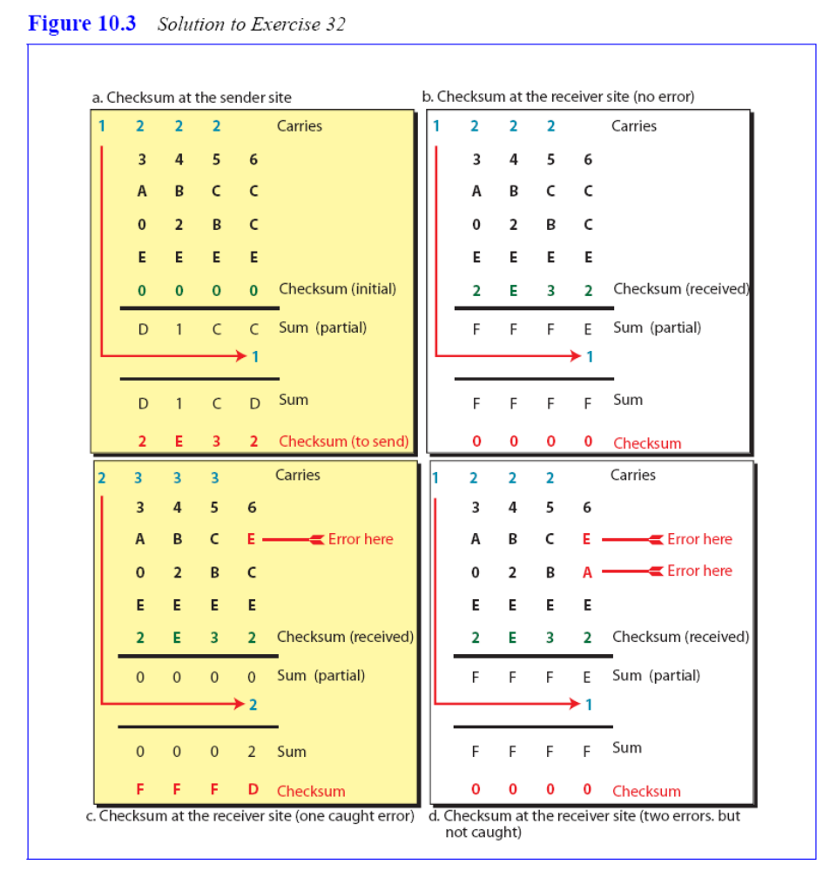
32 Figure 10.3 shows the four situations.
a. In part a, we calculate the checksum to be sent (0x2E32)
b. In part b, there is no error in transition. The receiver recalculates the checksum
to be all 0x0000. The receiver correctly assumes that there is no error.
c. In part c, there is one single error in transition. The receiver calculates the
checksum to be 0FFFD. The receiver correctly assumes that there is some error
and discards the packet.
d. In part d, there are two errors that cancel the effect of each other. The receiver
calculates the checksum to be 0x0000. The receiver erroneously assumes that
there is no error and accepts the packet. This is an example that shows that the
checksum may slip in finding some types of errors.

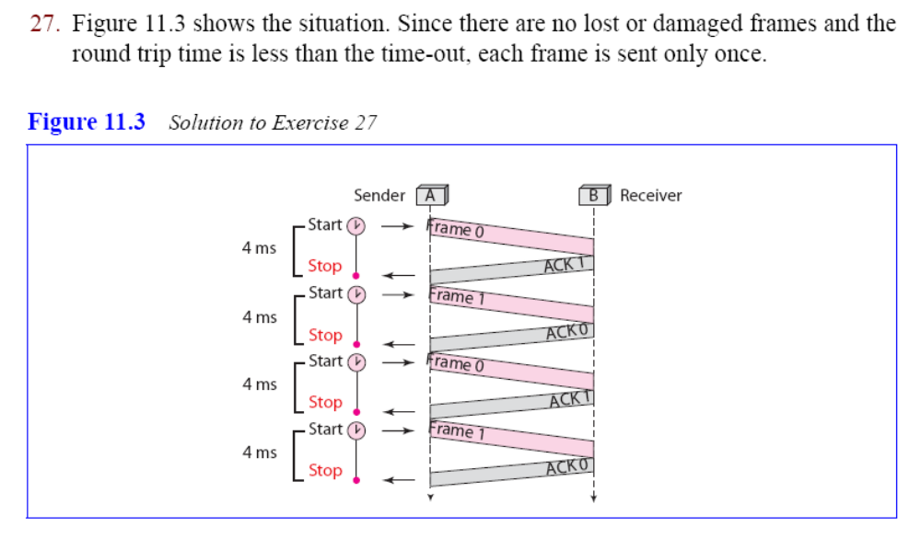
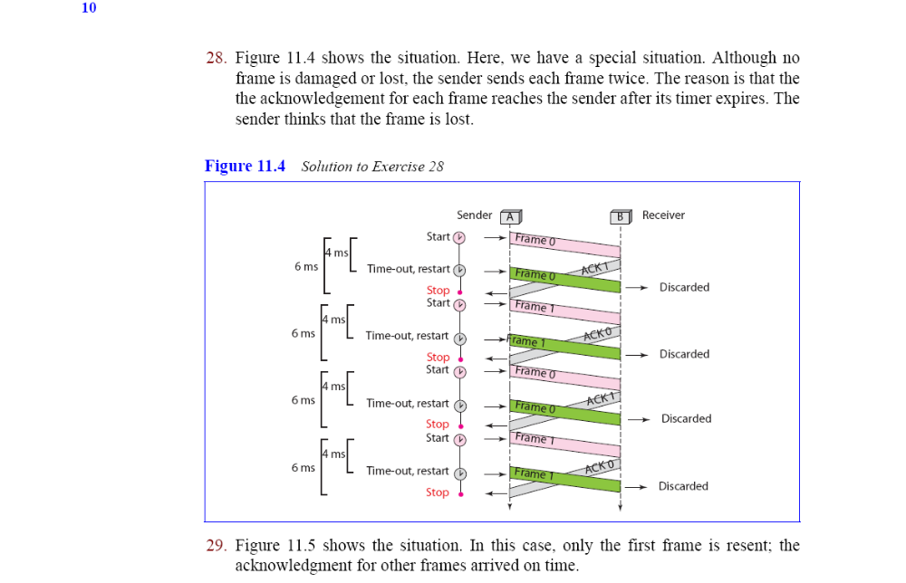
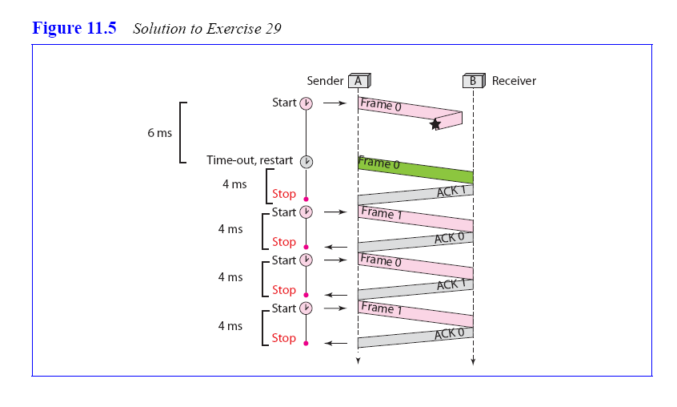
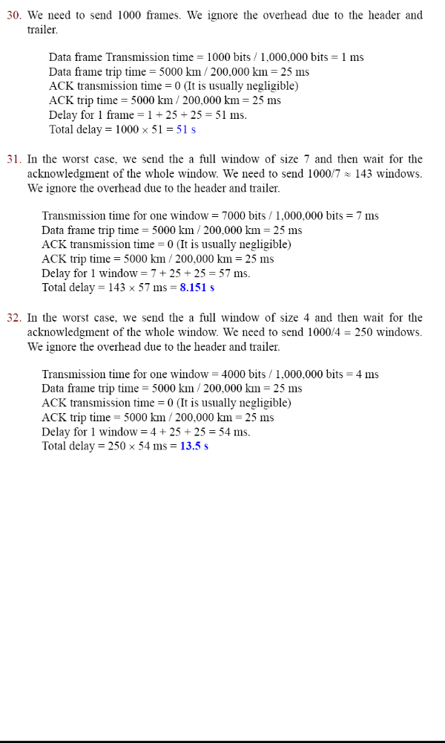
- Generate a table containing all 16 valid Hamming (7,4) codewords. Take several of these valid codewords and add them together (using the same modulo-two mathematics as used in polynomial calculations) – is there a pattern to the sums? Try adding several non-valid codewords to any of the 16 valid codewords – is there a pattern to these sums (possibly complementary to the previous pattern)? Based on these observations, can you make any assertion(s) regarding detectable and undetectable errors?
Message (M₇M₆M₅M₃) | P4 (=M₇+M₆+M₅) | P2 (=M₇+M₆+M₃) | P1 (=M₇+M₅+M₃) | Codeword (=M₇M₆M₅P₄M₃P₂P₁)
0000 | 0 | 0 | 0 | 0000000
0001 | 0 | 1 | 1 | 0000111
0010 | 1 | 0 | 1 | 0011001
0011 | 1 | 1 | 0 | 0011110
0100 | 1 | 1 | 0 | 0101010
0101 | 1 | 0 | 1 | 0101101
0110 | 0 | 1 | 1 | 0110011
0111 | 0 | 0 | 0 | 0110100
1000 | 1 | 1 | 1 | 1001011
1001 | 1 | 0 | 0 | 1001100
1010 | 0 | 1 | 0 | 1010010
1011 | 0 | 0 | 1 | 1010101
1100 | 0 | 0 | 1 | 1100001
1101 | 0 | 1 | 0 | 1100110
1110 | 1 | 0 | 0 | 1111000
1111 | 1 | 1 | 1 | 1111111
Any two codewords, when added together, generate another codeword. An invalid codeword added to a valid codeword generates an invalid codeword. Errors are undetectable only when they transform the transmitted codeword into another valid codeword, thus undetectable errors are those errors that are themselves codewords.
This is true of linear block codes in general. Cyclical redundancy checks (CRCs) are another form of linear block code and share this property – the only undetectable errors are those that are divisible by G(x) – and by definition, anything divisible by G(x) is a codeword. This can be seen if we model the received codeword C’(x) as the sum of the transmitted codeword, C(x) plus any error introduced, E(x): C’(x) = C(x) + E(x). An error will be undetectable only if G(x) | C’(x) – given that G(x) | C(x), then G(x) | C’(x) iff G(x) | E(x) (look back at your discrete math text regarding divisibility if this isn’t clear).
Note: This has an interesting interpretation in terms of the Hamming distance of a code. Remember that the Hamming distance of a code is the minimum number of bits required to transform one valid codeword into another valid codeword. Based on the above we know that that transformation must be the same as a valid codeword. Then the minimum number of 1 bits in any of the valid codewords (excluding the 0 codeword) is the same as Hamming distance of the code.

- Given the generator polynomial x⁴+x²+1,
  - Show the transmitted codeword (data plus CRC) for the message 110111101110101.
G(x) = 1x⁴+0x³+1x²+0x¹+1x⁰ = 10101
______________________
10101 ) 1101111011101010000
10101
11101
10101
10001
10101
10001
10101
10011
10101
11001
10101
11000
10101
11011
10101
11100
10101
10010
10101
11100
10101
1001
The codeword C(x) = 1101111011101011001 is transmitted to the receiver.
  - During propagation, the error 0000100001000000000 is introduced by the channel. Is the error detected or not? Show the receiver’s calculation to substantiate your answer.
C(x) = 1101111011101011001
+ E(x) = 0000100001000000000
C’(x)= 1101011010101011001
______________________
10101 ) 1101011010101011001
10101
11111
10101
10101
10101
0010101
10101
00000011001
10101
1100
The non-zero remainder indicates to the receiver that an error occurred in transmission.

- A 12000-km long fiber-optic cable is used to transmit 1024-byte frames using an ARQ protocol where acknowledgements are not piggybacked and are negligible in size. If the propagation speed through fiber is 6 microseconds/km and the data transfer rate is 128 kbps, how many bits should the sequence numbers be for:
  - Stop and Wait ARQ?
For Stop and Wait, SWS = 1. In this boundary case (minimum window size), Go-Back-N and Selective Repeat are equivalent, so either sequence space equation is applicable:
(Go-Back-N): SWS = 1 ≤ 2^{n} – 1, n ≥ 1-bit sequence space
(Selective Repeat): SWS = 1 ≤ 2^{(n-1)}, n ≥ 1-bit sequence space
  - Sliding Windows using Go-Back-N?
T_{frame} = 1024 bytes * 8 bits/byte / 128 kbps = 64 ms
T_{prop} = 12000 km * 6 microseconds/km = 72 ms
T_{ack} = 0 ms (negligible)
T_{rtt} = T_{frame} + T_{ack} + 2T_{prop} = 208 ms
SWS_{min} = ceiling( T_{rtt} / T_{frame} ) = 3 frames
SWS = 3 ≤ 2^{n} – 1
n ≥ 2-bit sequence space
  - Sliding Windows using Selective Repeat?
SWS = 3 ≤ 2^{n-1}
n ≥ 3-bit sequence space

- Both Telus and Sprint Canada have stated that they will be changing to a packet-switched telephone network infrastructure in place of current circuit-switching. Consider the scenario when the networks are under heavy load (i.e. Father’s Day) – how might the new packet-switched implementation behave differently from the former circuit-switched system?
If we define failure to be the inability of the system to deliver data from the source to the destination, then the point of failure differs for the two systems.
First consider a circuit-switched network. The first step in a circuit-switched system is to establish a circuit from source to destination (i.e. call setup). The switch implementations do not contain enough paths to interconnect all nodes simultaneously – see chapter 8 on circuit switching for details – and thus under heavy load, a path may not be available from a given source to the desired destination. Thus, at the start of a call, the circuit switched system may fail to find a path; however, once a circuit is established, data flows through that circuit without risk of failure. In terms of making a phone call then, during peak periods you may be presented with a message stating that all circuits are busy, please try again later, but only while trying to establish the call. Once connected, mellifluous tones of your voice flow smoothly to the destination.
In contrast, packet-switched networks do not establish a circuit initially, but instead route packets individually as they are introduced into the network. This provides a statistical advantage for packet-oriented traffic (including compressed, digitized voice traffic) as bandwidth is not dedicated needlessly to low-volume channels. However, without a dedicated path (circuit) and dedicated bandwidth along that path, the potential for congestion exists when the network is heavily loaded. In the case of congestion, packets will be dropped by the overloaded node. Note that this may occur at any point during transmission. Thus, failure (non-delivery of data) may occur at any point during transmission. In the case of voice traffic, this means that you may at any point in your conversation have ‘dead’ spots where your voice is not delivered – some may have experienced this phenomenon with their digital cell phones (although the cause of the lost data in that case is more likely due to unclean cell handoff rather then system congestion).

- Two neighbouring nodes (A and B) use a sliding window protocol with a 3-bit sequence number. As the ARQ mechanism, go-back-N is used with a window size of 4. Assume A is transmitting and B is receiving, show the window positions for the following succession of events:
  - before A sends any frames
  - after A sends frames 0, 1, 2 and B acknowledges 0, 1 and the ACKS are received by A
  - after A sends frames 3, 4, and 5 and B acknowledges 4 and the ACK is received by A

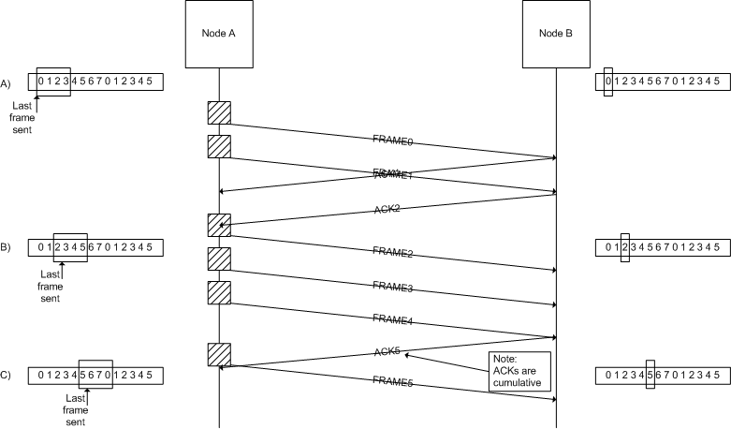

- Two stations wish to communicate over a network. There are 4 hops required to get from station to station. The data rate on all links is 9600 bps. Message length is 3200 bits. If packet switching is used, each packet size is 1024 bits which includes 16 header bits. Call setup time is 0.2 seconds. Calculate the total end-to-end delay for:

N = 4hops L = 3200bits B = 9600bps P = 1024bits H = 16bits S=0.2s D=0.001s

- Circuit switching

Define C1 = Call setup time
C2 = Message delivery time

Total Time (T) = C1 + C2

C1 = S C2 = D*N + L/B

T = C1 + C2 = 0.537s

- Message switching

Define M1 = Message delivery time for one hop

M1 = D + L/B = 0.334s

T = N*M1 = 1.337s

- Packet switching

Define Td = End-to-End delay
Np = Number of packets
D1 = Time to transmit and deliver all packets through the first hop
D2 = Time to deliver last packet through a hop

Np = ceil(L/(P-H)) = 4pkts
D1 = Np*(P/B) + D = 0.428s
D2 = P/B + D = 0.108s
Td = D1 + (N-1)D2 = 0.751s

Assume no delay at the nodes. Use the following variable names for deriving your delay equations:

N:# of hops between two given stations
L: Message length in bits
B : Data rate, in bps, on all links
P : Packet size in bits
H : Overhead (header) in bits
S : Call setup time (CS or VC) in sec’s
D : Propagation delay/hop in sec’s

Realistically, packet-switched networks carrying this type of traffic offer some form of virtual circuit switching or bandwidth reservation since customers are very sensitive to quality of service.

